**Creating source cards manual**

1. Crop and create a sub image from the table to use it as a ***reference image.png*** to set GAME_POSITION constant (x,y)

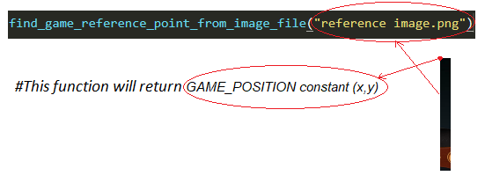

1. Find the other card coordinates in accordance with GAME_POSITION constant.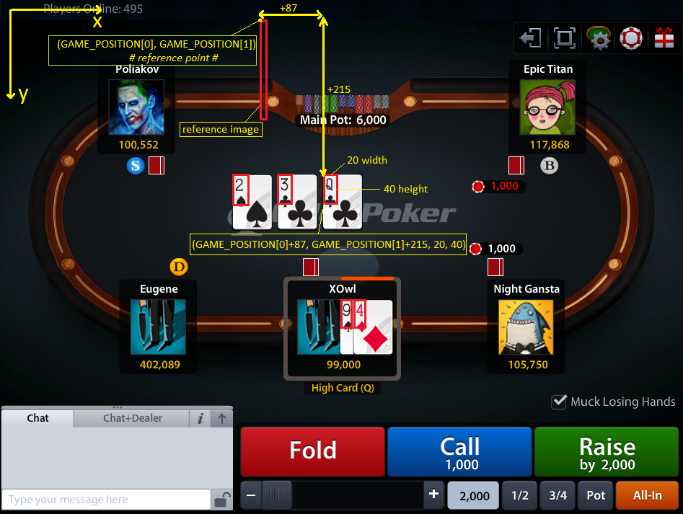
2. Set all 15 cards regions (5 table cards + 10 cards of mine if table is 5 player) inside ***crop_raw_card_image()*** function at ***create_source_cards_images.py*** module.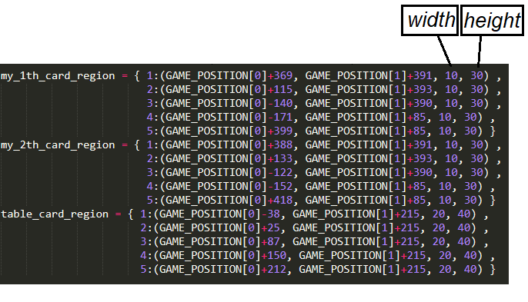
3. Set these coordinate as global constants at the beginning of ***create_source_cards_images.py*** module like below to crop suit and value from a card. (suit and value coordinates of table cards may differ from my cards, because the table card sizes may differ from my card sizes.)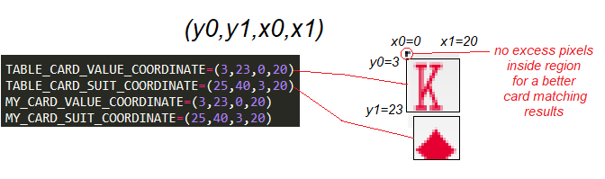

**Notes:**

1. Use specific top left corner pixel of a card as a sign to find and set similar card regions. 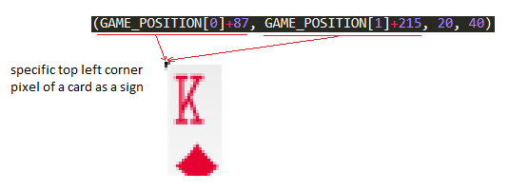
2. Set top left corner of table card regions to the same height from game position reference point.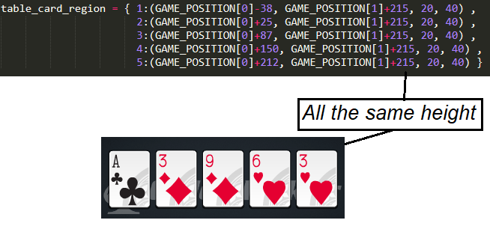
3. Fill ***'Raw Images/First Table Cards Raw Images'***  and ***'Raw Images/My First Cards From First Seat Raw Images'*** directories with 17 Sample cards .*png* images for each(13 value cards + 4 suit cards). And name the images like below: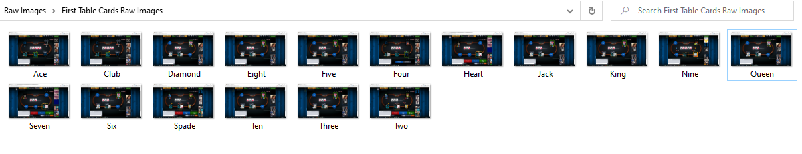

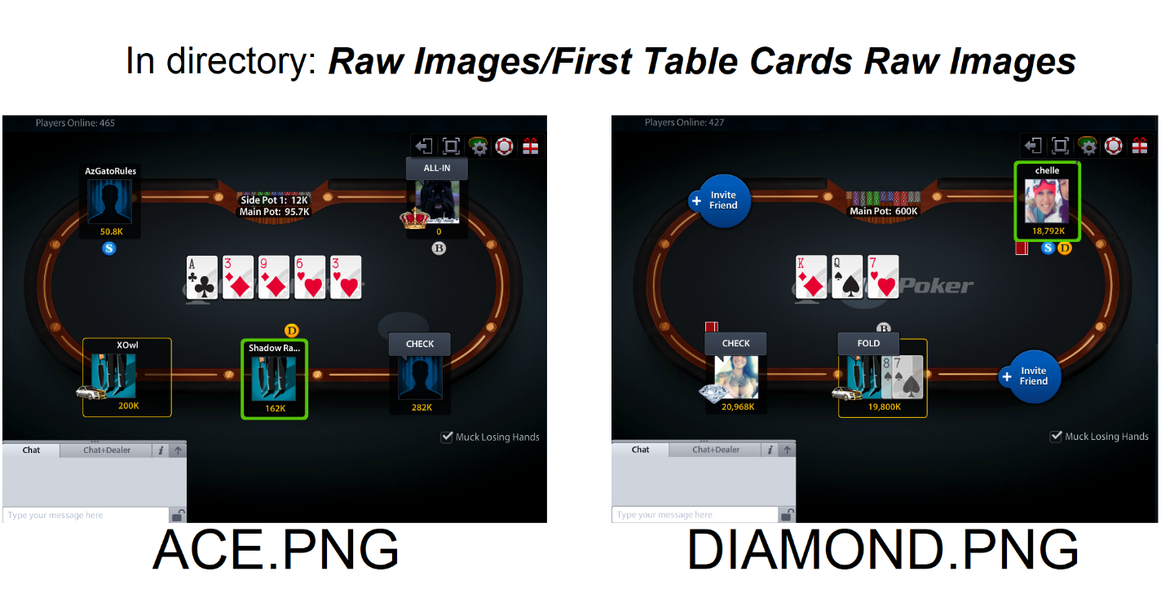

1. As the last step Run ***main()*** function at ***create_source_cards_images.py*** module, to create source cards Images.

***‘Source Card Images\Table Cards’***  directory should looks like below: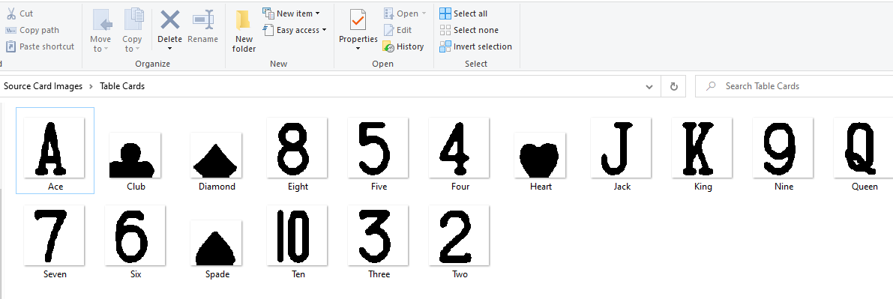

The source cards images are resized ×4, gray scaled, suit and values are cropped separately, and changed by threshold effect.

**Prerequisite for testing read_card.py module**

**1.**

**1.1.** Set these global constants at the beginning of **create_source_cards_images.py** and **match_card.py** modules the same:

***TABLE_CARD_VALUE_COORDINATE***, ***TABLE_CARD_SUIT_COORDINATE***,

***MY_CARD_VALUE_COORDINATE***, ***MY_CARD_SUIT_COORDINATE***, ***ZOOM*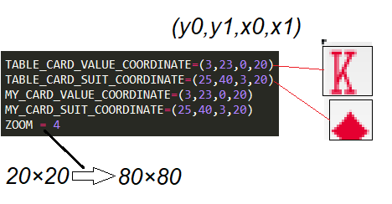**

**1.2.** Functions they are used in:

***create_source_cards_images.create_source_cards()***

and ***match_card.pre_process_query_image()***

**2.**

**2.1.** Set these constants the same between **create_source_cards_images.py** and **read_cards.py**:

***my_1th_card_region***, ***my_2th_card_region***, ***and table_card_region***



**2.2.** Functions they are used in:

***create_source_cards_images.crop_raw_card_image()***

and ***read_card.download_my_card() read_card.download_table_card()***